NEDSS Base System Design Overview:
Partner Services File

Release 6.0
September 20, 2018


Prepared by:

U.S. Department of Health and Human Services

Version History
Version # | Author | Reviewed By | Revision Date | Revision Notes
1.0
0.2
0.1 | Fatima Lopez Calzado | Christi Hildebrandt | 09/20/2018 | Initial version of this document.

Contents
1 Introduction 4
1.1 Purpose 4
1.2 Background & Scope 4
1.3 Document Organization and Usage 4
1.4 Key Terminology and Acronyms 5
2 PSF Overview 6
3 Populating the PSF Flat Tables 6
3.1 Batch file 7
3.2 Java class 8
3.3 Stored Procedure 8
3.4 Flat tables 9
3.4.1 Lookups 10
4 Generating the PSF XML 10
4.1 DT, DAO and Other Updated Java Files 10
4.1.1 DT 11
4.1.2 DAO 11
4.1.3 Other Updated Java Files 11
4.2 Generation of the PSF XML from the User Interface 13

Introduction

Purpose

This document provides an overview of the process followed within the NEDSS Base System (NBS) to generate the Partner Services File (PSF).
It includes:
- An overview of the purpose and usage of the PSF
- The steps followed within the NBS to populate the PSF flat tables in the NBS_MSGOUTE database
- The steps followed by the NBS to create the PSF XML

Background & Scope
This document provides a high-level overview of the PSF and describes the PSF key procedures, their purpose, and their behavior. The intended audience for this document is any user of the NBS that would like to:
- Better understand the PSF process in the NBS
- Be able to debug the PSF XML file using the data stored in the PSF flat tables

Document Organization and Usage
This document includes the following sections:
Section | Description | Usage
PSF Overview | Provides basic information on key changed introduced in NBS 6.0 to support generation of the PSF XML. | Read this section to better understand the high-level components used in the design for creation of the PSF XML out of the NBS.
Populate Flat tables | Provides an introduction to the process for populating the PSF tables. | Read this section to gain insights into the PSF flat tables, including a description of what the purpose of each table and the different steps involved in populating data in the tables - from the batch process to the tables in the database.
Generate the XML | Provides information about the generation of the PSF XML file. | Read this section to learn more about the generation of the PSF XML using the data from the flat PSF tables, including information on which Java files are used in the process.

Key Terminology and Acronyms

Key terminology and acronyms that are used in this document are described in the table:

Term | Acronym | Definition
Partner Services | PS | ‘Partner services’ are offered to individuals who are infected with STDs, to their partners, and to other persons who are at increased risk for infection in an effort to prevent transmission of these diseases and to reduce suffering from their complications.  For more information, see the following: https://www.cdc.gov/std/program/partners.htm.
Partner Services File | PSF | A file that can be uploaded to PartnerServicesWeb (EvaluationWeb) designed to meet all of the requirements reporting HIV Partner Services data and reporting CDC-required National HIV Prevention Program Monitoring & Evaluation (NHM&E) required variables.  http://lutherconsulting.com/partnerservicesweb.html
Luther Consulting |  | Luther Consulting is a provider of web-based public health software systems, including EvaluationWeb, which is used to upload the PSF for NBS sites.
Incremental Refresh |  | Rather than refreshing the entire tables, an incremental refresh only adds/updates the rows that are new or have been updated since the last time the batch process was run.
Full Refresh |  | Every time the batch process is run in full mode, all of the rows within the PSF tables are replaced with the data in the underlying data source (i.e., the ODS). This kind of refresh ensures you have an exact copy of what is in the underlying data source.
Index |  | Index aligns with the NBS concept of a Case (Investigation) with a disposition indicating HIV positive (1, 2, 5).
Session |  | Session aligns with the NBS concept of 'Interview'.
Client |  | Patient Revision either attached to an investigation or a contact record.
Risk |  | Risk profiles are collected on an investigation (not on a contact record). This occurs for both indexes and partners.
Partner |  | Contact to a case where referral basis is P1, P2, or P3.
Data Transfer ObjectsTable (?) | DT | Data Transfer Objects are Java objects that represent the attributes and the ‘getter’ and ‘setter’ methods for each of the columns in the PSF tables.
Data Access Object | DAO | Data Access Object files are used to retrieve the data from the data base and store it in the java objects.
Reporting Month |  | Month, which when combined with reporting year, will generate the data range of the data shown in the PSF. If the month selected is December, the date range will be January 1st-June 30th of that year. If the month selected is March, then the date range will be July 1st – December 31st of the previous year.
Reporting Year |  | Year, which when combined with reporting month, will generate the data range of the data shown in the PSF.

PSF Overview

With NBS 6.0, the partner services data that is used to generate the PSF from the NBS is now accessible in a flat file (table) format. This functionality was implemented to make it easier to pull the data necessary for the information included in the PSF, as well as to help with troubleshooting any data reconciliation issues. Five new tables have been added to the NBS_MSGOUTE database:
- PSF_CLIENT
- PSF_INDEX
- PSF_PARTNER
- PSF_RISK
- PSF_SESSION
These tables are further described below in this document.
The creation of the PSF XML consists of two key processes:
- Populating the flat tables
- Generation of the PSF XML (using the data stored in these flat tables)
Both of these processes are described in detail below.

Populating the PSF Flat Tables

There are four main processes that, together, populate the PSF tables in the MSG_OUTE database:
- User ‘kicks off’ the Batch process from the Command prompt.
- Java process checks to ensure a valid parameter has been entered.
- Java code calls a stored procedure with the corresponding parameter.
- Stored procedure populates the PSF tables.

Each of these processes is described in more detail in the following sections.

Batch file

In NBS 6.0, a new batch file has been introduced called: PopulatePSFTables.bat. This batch file calls the Java file, which will, in turn, call the stored procedure that populates the PSF flat tables. The batch process can receive 0 or 1 parameter, which indicates the type of ‘refresh’ that should be completed by the batch process:
- Full: If this option is indicated, the stored procedure will:
  - Drop all of the data from the existing PSF tables and then
  - Re-populate each of them with a full refresh of the current data in the ODSE.
- Incremental: If this option is indicated, the stored procedure will not drop the existing table data; it will update the existing table data for records where the stored procedure determines any change has been made and will append any new data. This is done by:
  - Deleting the records that have been updated since the last time the batch process was run and then
  - Appending data (records) to the tables for all data that has been updated or added since the last run time.
- No parameter: If no parameter is indicated, the stored procedure will interpret this as ‘incremental’., and the behavior is the same as in the previous scenario.
In order to execute the batch file, the user opens a command prompt and navigates to: “C:\wildfly-10.0.0.Final\nedssdomain\Nedss\BatchFiles” and uses one of the following commands (it is not case sensitive):
- PopulatePSFTables.bat full or
- PopulatePSFTables.bat incremental or
- PopulatePSFTables.bat (same as incremental)

Java class

The batch process doesn’t call the stored procedure directly. Instead, it calls a Java Class. This decision was made so that there is more control over the running of the stored procedure. The java class is: PSFBatchProcessor.java. This Java class will call the stored procedure. Before doing that, it will make sure to send the correct parameter to the stored procedure, translating no parameters to incremental. In case a non-valid option is sent from the batch process, Java will show an error message; otherwise, the stored procedure will be called and executed successfully.
Example of non-valid option:
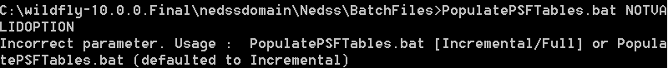

Stored Procedure

The stored procedure performs the following steps:
- The first thing the stored procedure does is look up the last time the batch process was run (please see the NBS_MSGOUTE Activity Log Table section of this document for more information about this lookup in the NBS_MSGOUTE..activity_log table).
  - If the parameter received is FULL, all the table data is removed.
  - If the parameter is INCREMENTAL, the stored procedure will check each of the tables to see if any of the data has been updated since the last time the batch process was run. If so, the record will be deleted.
- Next, inserts are performed. The inserts are based on the last time the batch process was run compared to the last updated date for records in the related ODSE table (e.g., person, public_health_case, CT_contact, interview, etc.). In order to have the same insert statement regardless of whether a full or incremental refresh is being run, the “where” statement contains a date representing the last time the batch process was run:
  - If a full refresh is being run, the date will be 01/01/1900 so that all the records are written in the tables.
  - If an incremental refresh is being run, the date will be read from the NBS_MSGOUTE..activity_log table (to determine the last time the PSF batch process was run).
- After the stored procedure runs, the PSF_INDEX.indexLastChgDt will be updated to reflect that last time the index data was refreshed. IndexLastChgDt is a column in the PSF_INDEX table that represents the most recent ‘last updated date’ for all records contained within the universe of PSF data (i.e., any of the flat file tables). For example, if an interview in the universe of the index was updated more recently than the index investigation, then the PSF_INDEX.indexLastChgDt will contain the last time the interview was updated.

  - NOTE: This indexLastChgDt will also be used by the NBS front end to know which index records need to be written in the PSF XML after selecting the reporting month and year.

NBS_MSGOUTE Activity Log Table

In order to know the last time the batch process was run, a new activity_log table has been created in the NBS_MSGOUTE database; it logs every time the batch process has been run and the status (success/failure) of each run.
Execute the following query, and the column add_time will indicate the last time the PSF batch process ran successfully:
SELECT TOP 1 add_time FROM NBS_MSGOUTE..activity_log
WHERE doc_type = 'PSF' AND message_status = 'Success'
ORDER BY 1 desc

Flat tables
With NBS 6.0,
five flat tables have been introduced in the NBS_MSGOUTE database that contain the necessary data for generating the PSF XML. These tables also provide a helpful reference to debug any issues found in the PSF XML:
- PSF_SESSION: Contains interview data.
- PSF_INDEX: Contains Cases (Investigations) with a disposition indicating HIV positive (1, 2, 5).
- PSF_CLIENT: Contains Patient Revisions, either attached to an investigation or a contact record.
  - It is important to note that the information comes from the most updated record in the person table for that person, (regardless of where the information is coming from). For example, if a Hepatitis case is entered for a patient, and it is the most patient revision that exists for a patient, then that patient revision data is what is pulled from the ODSE person table(s) and written to the PSF_CLIENT table for that patient (even though this data was entered/collected outside of the context of an HIV investigation – it reflects the most recently known patient demographics). Note that all revisions for a patient are considered, but the master patient record (MPR) IS NOT.
- PSF_RISK: Represents risk profile(s) on an investigation.
- PSF_PARTNER: Represents Contacts to a case where referral basis is P1, P2, or P3.

Lookups

Many of the data included in the flat file PSF tables has to be translated before writing this data to the tables. This translation is accomplished using an existing lookup table, NBS_MSGOUTE.. MSG_ANSWER_LOOKUP; in NBS 6.0, new records (lookups) with investigation_form_cd = 'GENERIC_PSF’ have been inserted as part of a script included in the NBS 6.0 release package. The procedure that translates the code relies on a new method called AnswerFromToCode. This method executes a query that selects from NBS_MSGOUTE.. MSG_ANSWER_LOOKUP using a from_code and a question_identifier, and it returns the corresponding translation. This provides an easy way to get the to_code for each of the data elements that requires translation before inserting the data in the corresponding PSF table.

This is an example of how to use the method in any select statement in SQL:
SELECT dbo.AnswerFromToCode(caseAnswer.answer_txt,'NBS445') AS careStatusAtInterview from …

Generating the PSF XML

The NBS user interface for generating the PSF XML has not been modified; it looks the same as it did in prior releases of the NBS:
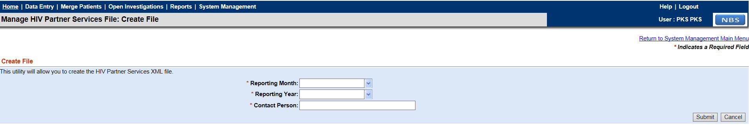
The user can select the reporting month, the reporting year, and a contact person. Once the submit button is pressed, if none of the required fields are missing, the Java classes take care of the rest of the process. If there are records for the reporting month/year, then a file will be downloaded. Otherwise an error message will be displayed letting the user know that there are no cases for that date range.

DT, DAO and Other Updated Java Files

When the Submit button is clicked the Java code is triggered.
The sequence of Java files (and methods) is:
- NNDMessageProcessorEJB.java: createHivPartnerServicesFile method
- PartnerServicesUtil.java: processPartnerServicesFileRequest method
  - PartnerServicesDAOV3.java:DAO methods for retrieving the data from the database
  - PartnerServicesHelper.java: buildPartnerServicesDocument method

DT

A DT class has been created for each of the flat tables under the folder NBS/source/gov/cdc/nedss/nnd/helper:
- PSFSessionDT.java
- PSFIndexDT.java
- PSFClientDT.java
- PSFRiskDT.java
- PSFPartnerDT.java
Each DT is an object representing a record from the corresponding PSF flat table where each attribute represents a column of the table. The DT also contains ‘getter’ and ‘setter’ methods for retrieving and storing the data in the object. In order to represent the all the records, a collection of DT objects is created for each table.

DAO

The DAO file is located under the folder: NBS/source/gov/cdc/ndss/nnd/ejb/nndmessageprocessorejb/dao, called:
- PartnerServicesDAOV3.java
The following new methods have been created to retrieve the information from the flat tables:
- getPSFSessionData: retrieves the data from the PSF_session table
- getPSFIndexData: retrieves the data from the PSF_index table
- getPSFClientData: retrieves the data from the PSF_client table
- getPSFRiskData: retrieves the data from the PSF_risk table
- getPSFPartnerData: retrieves the data from the PSF_partner table

Other Updated Java Files

NNDMessageProcessorEJB.java

The file that initiates this process is NNDMessageProcessorEJB.java. The method used is createHivPartnerServicesFile, which hasn’t changed in NBS 6.0.

NNDMessageProcessorEJB.java

From the previous method createHivPartnerServicesFile, the function PartnerServicesUtil.processPartnerServicesFileRequest is called; this function:
- Generates the date range based on the reporting month and year.
- Uses the methods in PartnerServicesDAOV3.java for getting the data from the database.
- Uses the method PartnerServicesHelper. buildPartnerServicesDocument for generating the PSF XML.

PartnerServicesDAOV3.java

This file contains the DAO methods for retrieving the data from the database:
- getPSFIndexData: the records read should have an indexLastChgDt in the date range selected from the UI.
- getPSFSessionData: get the session records for a specific caseNumberLocalId.
- getPSFClientData: get the session records for a specific clientIdLocalId.
- getPSFRiskData: get the session records for a specific clientIdLocalId.
- getPSFPartnerData: get the session records for a specific clientIdLocalId.

PartnerServicesHelper.java:

This is the last step. This file contains the buildPartnerServicesDocument method, which is responsible for generating the PSF file using the data stored in the DT collections. The data is filled following this schema:

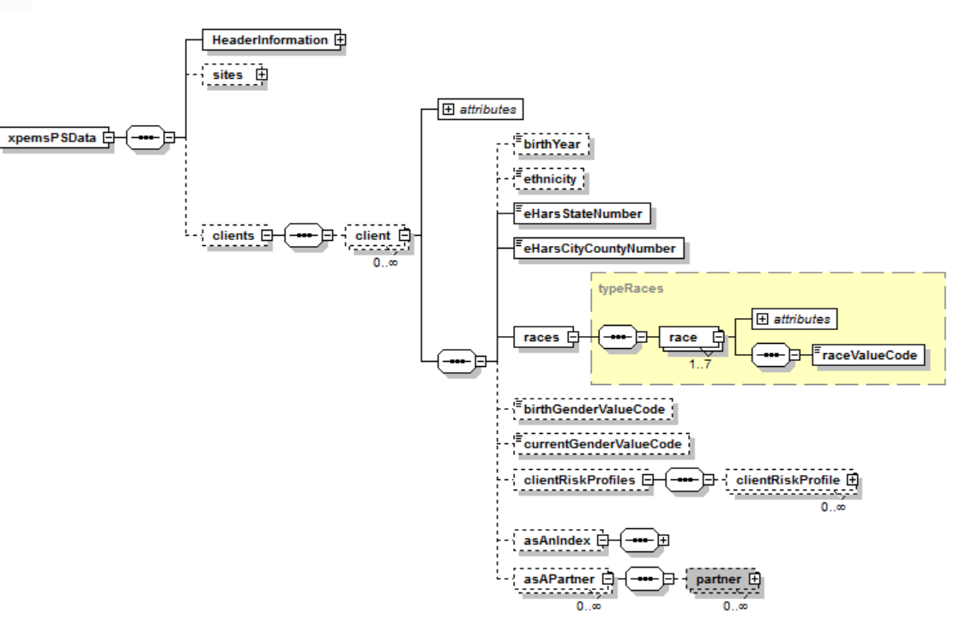

Generation of the PSF XML from the User Interface

The logic used to generate the PSF XML is:
- Based on the reporting month and year a date range is created.
- Based on that date range, all the records from psf_index with indexLastChgDt in that range will be read.
- For each of the psf_index records, the caseNumberLocalId and the clientIdLocalId are read.
  - The caseNumberLocalId is used to retrieve sessions (for sites).
  - The clientIdLocalId is used to retrieve clients, risk and partner data.

- Once all the data has been compiled in a useful structure (collections and maps), the PSF data is ready for populating the PSF XML file.
- The method that will create the PSF XML is called: buildPartnerServicesDocument. This method populates:
  - Header Information
  - Sites
  - Clients, Risk, Partner and Session

